Mortgage Relief FAQs
While you may have gotten a loan from your bank, ultimately many loans that are $650,000 or less are sold to Fannie Mae, Freddie Mac, the FHA or the VA and are serviced by a bank. If your original loan balance was $650,000 or less and you are facing economic hardship as a result of the COVID-19 situation, you may be eligible for mortgage relief through forbearance for up to 12 months. In order to qualify for this relief, you do not have to be infected with the virus. A moratorium has also been issued that halts foreclosures and evictions by 60 days for loans owned by Fannie Mae, Freddie Mac or the FHA.
Forbearance means that you are able to reduce or suspend your mortgage payments for a specified period of time. Fannie Mae, Freddie Mac, the FHA and the VA have also made clear that if a borrower qualifies for a forbearance plan as a result of the COVID-19 situation:
- they will not incur late fees,
- late payments will not be reported to credit bureaus and will not count against a borrower’s credit score,
- after the forbearance period ends, a servicer must work with the borrower on a permanent workout option to help maintain or reduce monthly payment amounts if necessary, including a loan modification.
In order to obtain forbearance, you should call your servicer, explain your hardship and mention that you know that you can qualify for forbearance given your circumstances.
How do you know if your loan is owned by Fannie Mae, Freddie Mac, the FHA or the VA?
On your loan statement is a loan number (or sometimes called the account number) that is in the same box as the monthly payment amount:
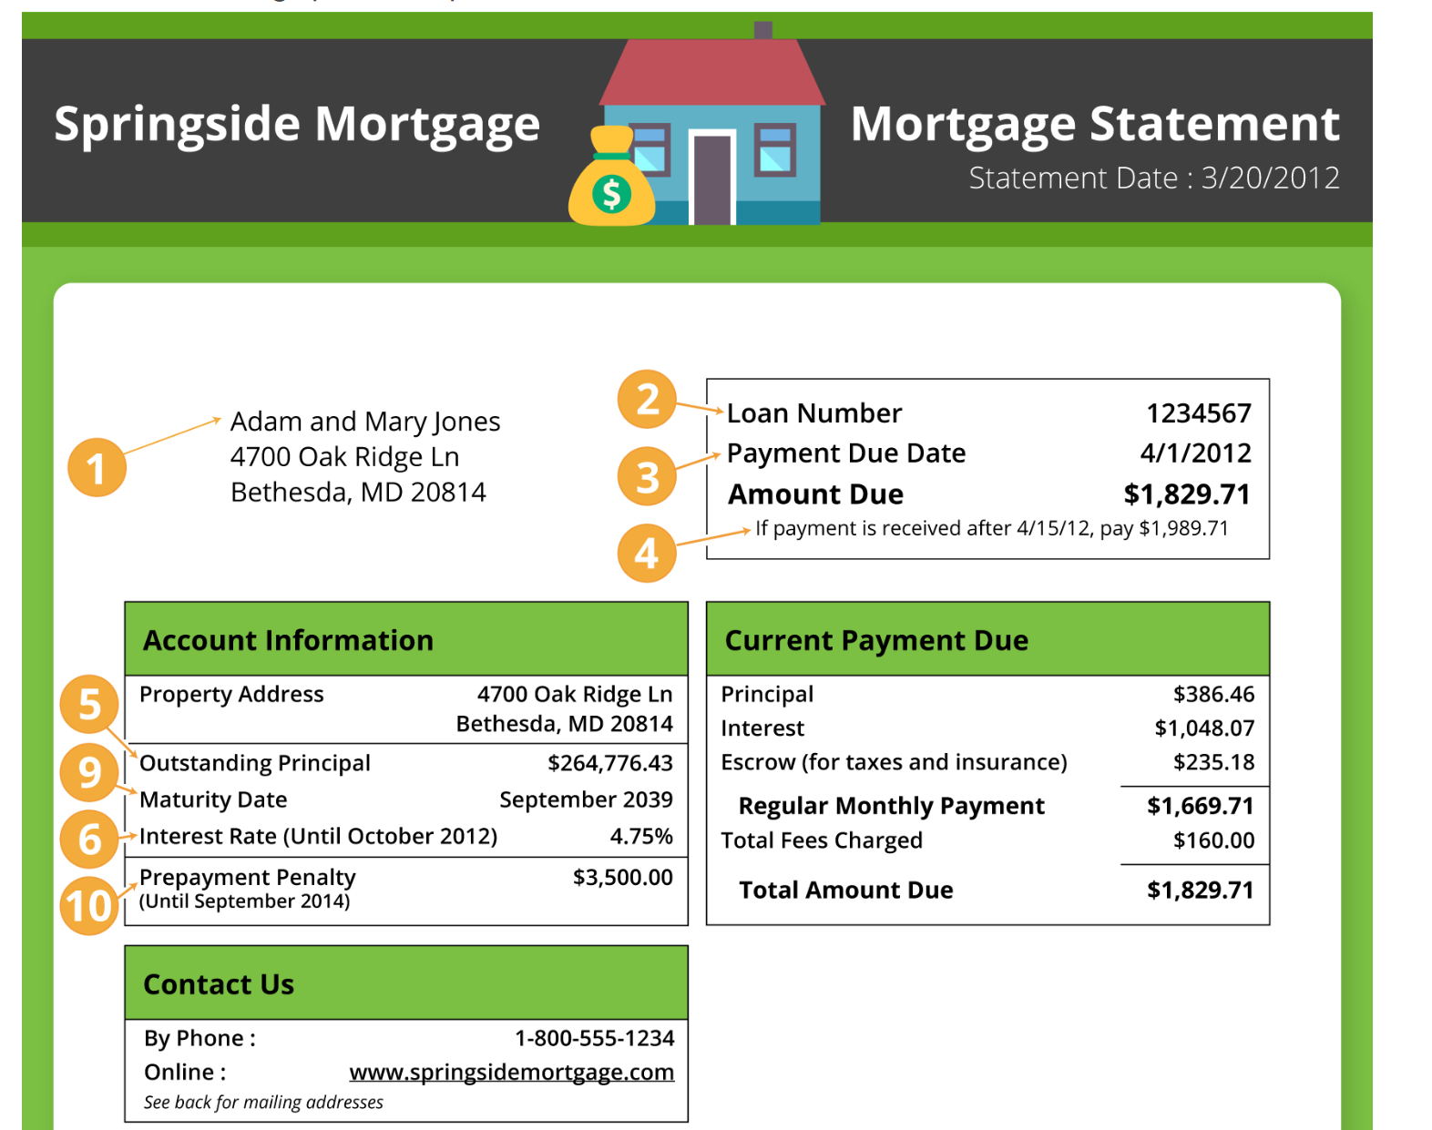
You can use that loan number/account number to figure out who owns your loan by going to the links below and entering your information. If your loan does not register at any of the below links, call your lender or servicer (we talk about how to figure out who your servicer is below).
- Fannie Mae: https://www.knowyouroptions.com/loanlookup
- Freddie Mac: https://ww3.freddiemac.com/loanlookup/
- FHA or VA loans: call your servicer
How do you know who your servicer is?
A mortgage servicer is a company that collects your monthly mortgage payments. Your servicer could be the same company or bank that issued your mortgage or it could be a different company.
The company that you get your mortgage statements from is your servicer. In the above sample statement, the servicer would be Springside Mortgage.
If you don’t have a loan statement, you can type your address into the following link and it will give you the servicer information: https://www.mers-servicerid.org/sis/.
What if your loan is not owned by Fannie Mae, Freddie Mac, FHA or VA?
Call your servicer, explain your hardship and find out if there are any opportunities for relief given the current situation.
You can also get in touch with the Hope Hotline https://995hope.org/ or call 1-888-995-HOPE to talk to housing counselors who can help you understand what your options are.
How about if you’re a renter and experiencing hardship due to the COVID-19 situation?
If you live in a property financed by Fannie Mae, there could be some relief. Ask your landlord, building manager or rental company if they know or can find out if your building is financed by Fannie Mae https://multifamily.fanniemae.com/sites/g/files/koqyhd161/files/2020-03/covid-19-disaster-response_1.pdf.
Student Loan Relief FAQs
Under the stimulus package passed by the Senate on late Wednesday, federal student loans will automatically have their interest rates set to 0% for a period for six months. Additionally, borrowers do not have to make payments during that six-month period.
Borrowers should log on to their student loan servicer’s website to access their account. From there, they should see that there is no payment due. If the system is still showing a payment due, contact the servicer to confirm that a payment is not required.
Until the stimulus package is signed into law, borrowers should tread carefully before deciding to stop making payments. It could be wise to contact federal student loan servicers directly to confirm they are putting the government’s guidance into action, or to check information posted to their websites.
Below are the federal student loan servicers’ phone numbers and websites:
- CornerStone: 1-800-663-1662
- FedLoan Servicing (PHEAA): 1-800-699-2908
- Granite State — GSMR: 1-888-556-0022
- Great Lakes Educational Loan Services, Inc.: 1-800-236-4300
- HESC/Edfinancial: 1-855-337-6884
- MOHELA: 1-888-866-4352
- Navient: 1-800-722-1300
- Nelnet: 1-888-486-4722
- OSLA Servicing: 1-866-264-9762
- ECSI: 1-866-313-3793

